1)

var value

value = prompt("What is your name?","")

user = value.toLowerCase();

var firstsymbol = user.slice(0, 1)

alert("Hello " + firstsymbol.toUpperCase().concat(user.slice(1, user.length)))

2)

function main(){

putBeeper();

beepBeep1();

beepBeep3();

beepBeep2();

putBeeper();

turnRight();

beepBeep1();

beepBeep3();

beepBeep2();

turnRight();

putBeeper();

beepBeep1();

}

function beepBeep1(){

move();

move();

putBeeper();

move();

move();

putBeeper();

}

function beepBeep2(){

putBeeper();

move();

move();

putBeeper();

move();

turnRight();

move();

}

function beepBeep3(){

turnLeft();

move();

turnLeft();

move();

}

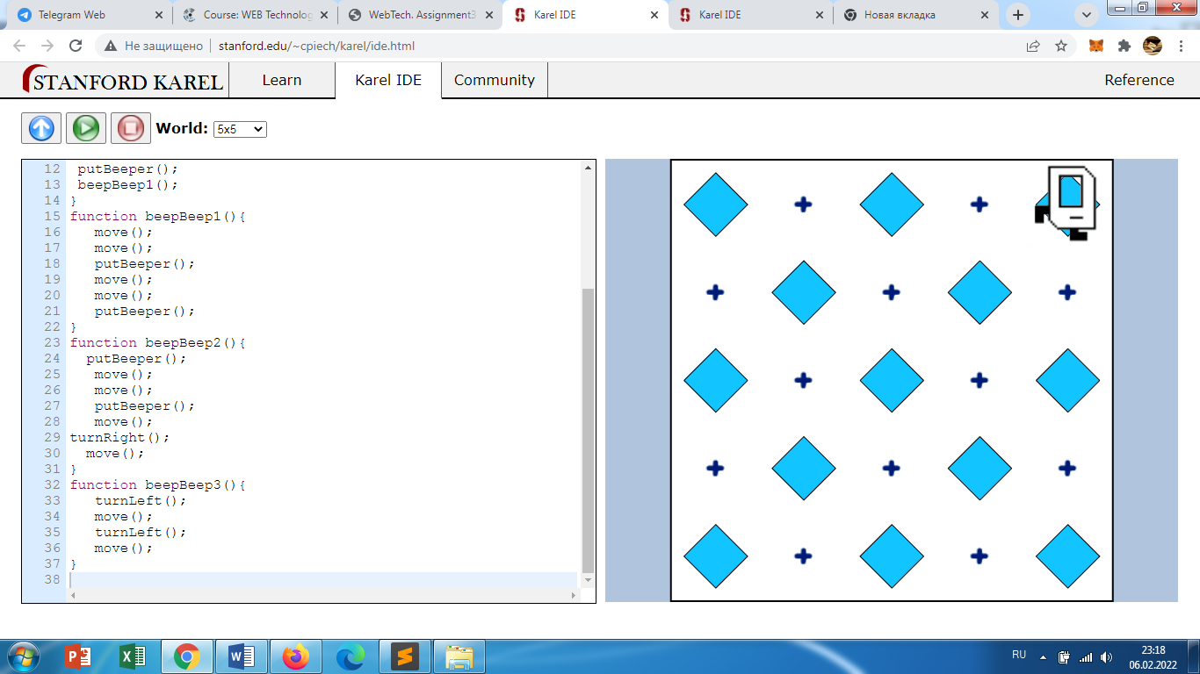

3)

function main(){

putBeeper();

beepBeep1();

move();

move();

move();

beepBeep2();

beepBeep1();

beepBeep2();

move();

beepBeep2();

beepBeep2();

beepBeep1();

beepBeep2();

beepBeep1();

beepBeep1();

move();

beepBeep2();

beepBeep1();

beepBeep2();

beepBeep1();

beepBeep1();

move();

beepBeep1();

beepBeep2();

move();

beepBeep2();

beepBeep1();

putBeeper();

}

function beepBeep1(){

turnLeft();

move();

}

function beepBeep2(){

turnRight();

move();

}

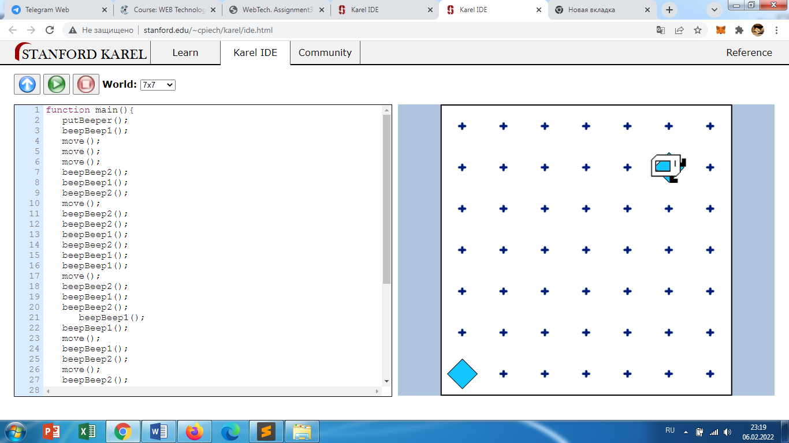

4)

function WeeksLeft(CurrentAge){

var age = 90 - CurrentAge;

var months = age * 12;

var weeks = age * 52;

var days = age * 365;

console.log("You have " + days + " days, " + weeks + " weeks and " + months + " months left.");

}

WeeksLeft( CurrentAge = prompt("How old are you?"));

5)

<!DOCTYPE html>

<html>

<head>

<script src="bmi2.js"></script>

</head>

<body>

<div class="container">

<p>Height (in cm)</p>

<input type="text" id="height">

<p>Weight (in kg)</p>

<input type="text" id="weight">

<button id="btn">Calculate</button>

<div id="result"></div>

</div>

</body>

</html>

**Js**

window.onload = () => {

let button = document.querySelector("#btn");

button.addEventListener("click", calculateBMI);

};

function calculateBMI() {

let height = parseInt(document

.querySelector("#height").value);

let weight = parseInt(document

.querySelector("#weight").value);

let result = document.querySelector("#result");

if (height === "" || isNaN(height))

result.innerHTML = "Provide a valid Height!";

else if (weight === "" || isNaN(weight))

result.innerHTML = "Provide a valid Weight!";

else {

let bmi = (weight / ((height * height)

/ 10000)).toFixed(2);

if (bmi < 18.6) result.innerHTML =

`so you are underweight : <span>${bmi}</span>`;

else if (bmi >= 18.6 && bmi < 24.9)

result.innerHTML =

`so you have a normal weight : <span>${bmi}</span>`;

else result.innerHTML =

`so you are overweight. : <span>${bmi}</span>`;

}

}

6)

function LeapYear(year) {

if (0 == year % 4 && 0 != year % 100 || 0 == year % 400) {

console.log(year + ' is a leap year');

}

else {

console.log(year + ' is not a leap year');

}

}

const year = prompt('Enter a year:');

LeapYear(year);

7)

<!DOCTYPE html>

<html>

<head>

<meta charset = "utf-8">

<title>Array random</title>

</head>

<body>

<script src = "arr.js" charset = "utf-8"> </script>

<form>

<input type="button" onClick="random()" Value="Activate" ></form>

<hr><br><br>

<p> <span id = "result"> is going to buy lunch today.</span></p>

</body>

</html>

**js**

function random(){

var arr = ['Aidana', 'Bekbolat', 'Mariya', 'Aleksandr', 'Diana'];

const winner = arr[Math.floor(Math.random() * arr.length)]+" is going to buy lunch today.";

document.getElementById("result").innerHTML = winner;

}

8)

<!DOCTYPE html>

<html>

<head>

<meta charset = "utf-8">

<title> Fibonacci</title>

</head>

<body>

<h1>Just relax</h1>

<script src = "fibb.js" charset = "utf-8"> </script>

</body>

</html>

</body>

</html>

**JS**

var n1 = 0;

var n2 = 1;

var nextNumber;

var i;

var num = parseInt (prompt (" Give the limit for sequence"));

document.write( "Fibonacci numbers : ");

for ( i = 1; i <= num; i++)

{ document.write (" " + n1);

nextNumber= n1 + n2;

n1 = n2;

n2 = nextNumber;

}